Comic Strip :
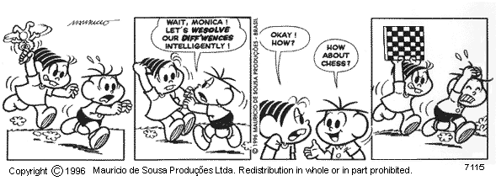
What are the characters’ names?
Monica and Cebolinha
Rewrite correctly the words ‘wesolve’ and ‘dif’fwences’
Resolve and differences.
Explain Monica’s unexpected attitude.
Cebolinha suggested that they should make up intelligently (without fighting, in this context), with a game like chess, but since she was angry at him, Monica willfully misinterpreted his statement and decided to hit him with a chess board instead.

Faça perguntas que se encaixem com as respostas abaixo  - My friends swam in the lake.  Where did your friends go swim?  - He paid the bill.  Did he pay the bill?  - The teacher pointed to the board.  What did the teacher point at?  - They felt good.  How did they feel?  - He hurt his leg because he was not careful. Why did he hurt his leg? | Passe as sentenças para a forma interrogativa  Billy ate an apple - Did Billy eat an apple?  The children played in the garden - Did the children play in the garden?  Laura came home at six o'clock - Did Laura come home at six o’clock?  The boy read a book - Did the boy read a book?  The girl wrote five letters - Did the girl write five letters?

Focus on grammar - writing activity
1)Make the past simple negative:
a. (I / not / go out last night)
I didn’t go out last night.
b. (you / not / come to the party)
You didn’t come to the party.
c. (she / not / love chocolate as a child)
She didn’t love chocolate as a child.

2) Passe as sentenças do exercício acima para a forma afirmativa:
a. I went out last night

b. You came to the party.

c. She loved chocolate as a child.

3) Passe as sentenças do exercício acima para a forma interrogativa:
a. Did you go out last night?

b. Did you come to the party?

c. Did she love chocolate as a child?

Put the verb "to be" into the simple present or the simple past: I am an engineer. Last year I was a student in Massachusetts Institute of Technology. I was in love with a beautiful girl at that time. We were friends. Now, I live in New York and I am married to her.

RESPONDA SOBRE VOCÊ MESMO

- What did you do this weekend?
I tried recording a podcast with a few friends of mine.
- Who was your first crush?
I don’t think I’ve ever had a significant crush.
- What did you watch on television recently?
I don’t watch television, but I always overhear COVID-19 related news when my parents are watching the news.
- What did you eat for breakfast?
Waffles with chocolate.
- What was the best meal you ate recently?
Homemade burgers.
- What tech problems did annoyed you recently?
We had a power outage a few days ago and I had no internet for a few hours.
- Where did you hang out with your friends last?
I had two friends come over on my birthday. We were wearing masks the entire time, though.
- Which was better for you: elementary school, junior high school or high school? Why?
Junior high school, just because high school hasn’t been good for anyone in it right now, I imagine. And I can’t remember anything from elementary school.
- How did you come here?
I don’t understand the question.

